Question1. Determine the root node, a leaf node, and an internal node for the following Binary Search Tree (BST). What is the height of the tree? Write preorder, post-order, in-order traversal of the following binary search tree ?

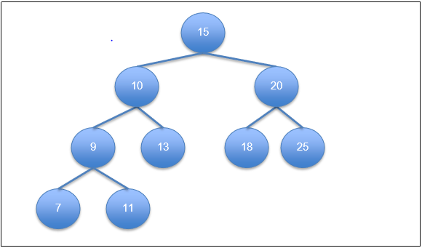

* The Root Node : 15
* The Leaves Nodes : 7 , 11 , 13 , 18 , 25
* The internal Nodes : 10 , 20 , 9
* The height of the tree :

h = log((n+1)/2)

h = log((9+1)/2)

= log(10/2)

= log(5) = 3

* Pre-order : (root-L-R)

15 10 9 7 11 13 20 18 25

* post-order : (L-R-root)

7 11 9 13 10 18 25 20 15

* inorder : (L-root-R)

7 9 11 10 13 15 18 20 25

Question 2. Write an algorithm or a pseudocode for pre-order, post-order, and inorder tree traversal.

* Algorithm pre-order

1. If the tree is not null .
2. Visit the root .
3. Traverse the left subtree , i.e , call recursive (pre-order(left-subtree)).
4. Traverse the right subtree , i.e , call recursive(pre-order(right-subtree)).

* Algorithm post-order

1. If the tree is not null .
2. Traverse the left subtree , call recursive(post-order(left-subtree)).
3. Traverse the right subtree , call recursive(post-order(right-subtree)).
4. Visit the root .

* Algorithm inorder

1. If the tree is not null .
2. Traverse the left subtree , call recursive(inorder(left-subtree)).
3. Visit the root .
4. Traverse the right subtree , call recursive(inorder(right-subtree)).

Question 3. Write a program that enables the user to construct a binary search tree of integers. Implement the following operations on the BST. Insert a node in the tree, search for a node, delete a node, and compute the sum of all the nodes. The following menu is to be displayed to the user when starting the program.

suppose my tree is :

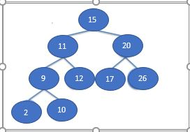

Sample output of run :

